2.2: a) The magnitude of the average velocity on the return flight is

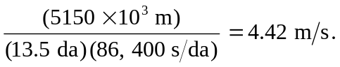

The direction has been defined to be the –x-direction 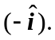

b) Because the bird ends up at the starting point, the average velocity for the round trip is 0.

